

08

Fall

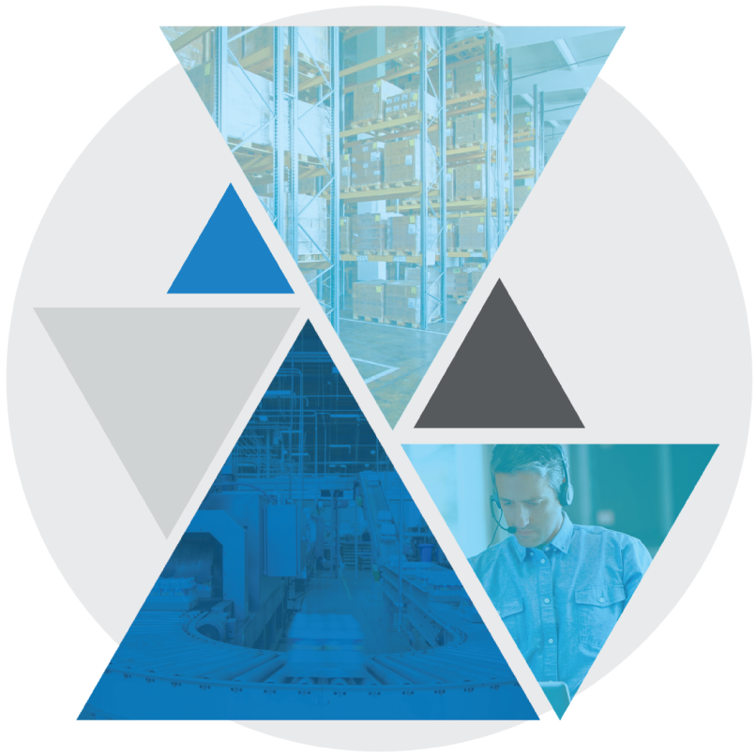

**Test Case: BASE-YRD-1030**

**Web Inbound Trailer Check In with Safety Check**

Table of Contents

Web Inbound Trailer Check In with Safety Check 3

Test Case Setup 3

Test Case Cleanup 3

Test Case Prerequisites and Assumptions 4

Test Case Examples 4

Test Case Specification 5

Test Case Configurations 5

Test Case Verification Approach 5

Web Inbound Trailer Check In with Safety Check

This document documents the test case instructions for the BASE-YRD-1030 Bundle Test Case implementing Web Inbound Trailer Check In with Safety Check.

**Please note**: The inputs used in these test case specifications (defined in the input CSV files or Datastore) are relative to our testing warehouse environment and are provided as examples. These inputs should be substituted with valid inputs relative to your WMS environment.

Test Case Setup

* Test Case Background function will run the standard set of setup scenarios for the bundle.
* Test Case Dataset
  + Creates a trailer
  + Checks in the trailer to the specified dock location

Test Case Cleanup

* The Test Case After Scenario will run the standard cleanup actions for the bundle.   
  **NOTE:** This including logging out of all interfaces (Terminal and Web).
* Data created during dataset creation and execution is cleaned up.

Test Case Prerequisites and Assumptions

* The dock location provided in the Input CSV file should be empty for successful execution of the test.
* User must have permissions to perform trailer moves

Test Case Examples

This Test Case will only perform Web Inbound Trailer Check in with Safety Check and will not perform any other examples of this function.

Test Case Configurations

The Test Case will be run in the following test configurations:

* Blue Yonder Web UI
  + Google Chrome
  + Microsoft Edge

Test Case Verification Approach

This test will verify screen data in-line within the test step sections.

It will also Utilize a MSQL WMS query to validate that the anticipated end state was reached.

Test Case Specification

|  |  |
| --- | --- |
| **Test Case:** BASE-YRD-1030 Web Inbound Trailer Check In with Safety Check | **Description:** Base-YRD-1030 Web Inbound **Functional Area:** Inbound **Test Case Type:** Regression **Dataset:** Datasets/Base/Inbound_Trailer **Test Case Inputs:** Test Case Inputs/BASE-YRD-1030.csv **Duration:** 1 minute (per example) |

|  |  |
| --- | --- |
| **Steps, Actions, and Expected Results** | **Supporting information and/or Affected Data** |
| **Step 1**: Sign into the Web UI using your relevant Username and Password  **Actions**:   * Enter Username and Password * Click on the **Sign In** button   **Expected Results**:   * User successfully logs on to web. |  |

|  |  |
| --- | --- |
| **Step 2**:  Search for Transport Equipment Web screen  **Actions**:   * Type ‘Transport Equipment’ in JDA search filed and press ENTER   **Expected Results**:   * Relevant pages are returned from the search. |  |

|  |  |
| --- | --- |
| **Step 3**: Navigate to Transport Equipment Web page  **Actions**:   * Select **Receiving -> Transport Equipment**   **Expected Results**:   * Transport equipment screen is open now |  |

|  |  |
| --- | --- |
| **Step 4**: Search for relevant transport equipment  **Actions**:   * Enter the transport equipment number in filter field * Press ENTER   **Expected Results**:   * The Transport equipment details will show up on the screen |  |

|  |  |
| --- | --- |
| **Step 5**: Check in transport equipment  **Actions**:   * Select desired transport equipment row * Click on the **Actions** drop down menu * Select **Check In** Transport Equipment   **Expected Results**:   * The *Check In* page is open |  |

|  |  |
| --- | --- |
| **Step 6**: Select the relevant dock door to check in the transport equipment  **Actions**:   * Select the relevant dock door from the list of recommened doors * Click the **Check In** button   **Expected Results**:   * The transport equipment is checked into the relevant dock door |  |

|  |  |
| --- | --- |
| **Step 7**: Verify succesful equipment check in  **Actions**:   * Click **OK** after the pop up box confirming successful check in appears.   **Expected Results**:   * Transport equipment has been successfully checked in. |  |

|  |  |
| --- | --- |
| **Step 8**: Perform Safety Check on equipment  **Actions**:   * Click the **Safety** button below the desired equipment * Click the **Perform Safety Check** button in pop up   **Expected Results**:   * The *Safety Checks* window is now open |  |

|  |  |
| --- | --- |
| **Step 9**: Perform Safety Check inputs  **Actions**:   * Click the four **Pass** buttons shown in the window * Click the **Save** button to complete and close windows   **Expected Results**:   * *Transport* *Equipment* page is now visable |  |

|  |  |
| --- | --- |
| **Step 10**: Remove and reapply search filter  **Actions**:   * Click the X on the right side of the Ad-Hoc filter * Re enter the transport equipment number in filter field * Press ENTER   **Expected Results**:   * The transport equipment details will show up on the screen |  |
| **Final State:** Verify Safety Check status as Passed  Standard test verification and log off functions are performed |  |